Student Name and Number: Qingyuan Wu, 1007001664 PRA Group: PRA5

Student Name and Number: Regis Zhao, 1007070660

**THE OUTPUT RESISTANCE OF A POWER SUPPLY**

Working with your partner, answer the questions in this exercise and submit them as a single file (including tables, figures, etc.) via Quercus by 11:59 on the Tuesday following your session. This is not as formal as Lab 1 and Lab 2 which you will do later in the term but make sure that your submission contains the title, both of your names, and the date.

**Objectives:** to review basic electrical measurement techniques; analyze uncertainties of direct and indirect measurements; understand error propagation; apply curve fitting to the set of data points; calculate uncertainty in linear fit.

**I. Introduction**

Any source of electrical energy (generator, battery, thermocouple, etc.) with no load attached to it produces voltage potential across the terminals called an electromotive force (*emf*), or an open-circuit voltage*, $V_{∞}$* .

This number does not completely specify the power supply. In a closed circuit, a current ***I*** will be drawn from the power supply, and the voltage at the terminals, $V$, called *the terminal voltage*, will typically fall below $V_{∞}$. A plot of what the terminal voltage $V$ vs. current $I$ may look like is shown in Fig. 1.

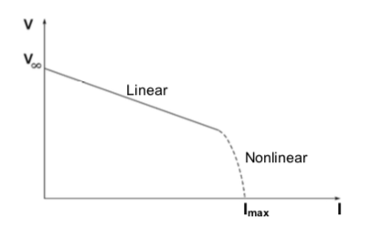

*Fig. 1. Terminal voltage vs. current*

Many power sources will exhibit a linear variation of *V* for small current values, followed by a nonlinear behaviour at higher currents. The linear part of the curve can be described by

$V=V_{∞}-RI,$ (1)

where $R$ is the *output resistance of the power source*. In this linear regime, according to Thevenin’s theorem, the power source is completely represented by this equivalent circuit as in Fig. 2.

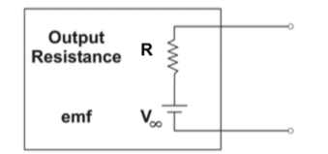

*Fig. 2. Equivalent circuit of an electric power source.*

The output resistance ($R$) can be determined by attaching different external resistances of the load ($R_{l}$)to the power source, and measuring the current and voltage with a multimeter. Figure 3 shows two possible ways of doing this. Both would be equivalent if the multimeter were ideal. However, in this exercise we will measure with real, not ideal, multimeters.

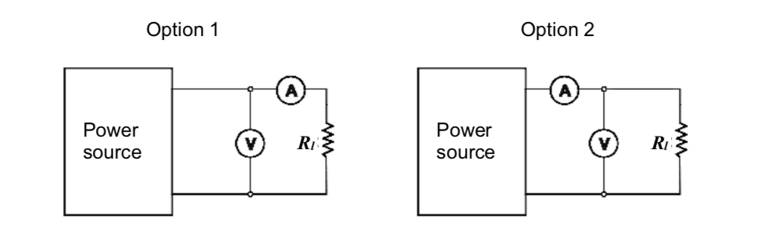

Fig. 3. Possible circuits for determining the output resistance of a power source.

**Question 1:**

**Without connecting circuits and making measurements, how would you expect the readings of the voltmeter and the ammeter to differ between Option 1 and in Option 2?** **Explain.**

We expect the reading of the voltmeter from Option 2 to be lower than that of Option 1 because in Option 2, there is a slight voltage drop across the ammeter before the location at which the voltmeter is connected. We expect the reading of the ammeter from Option 1 to be lower than that of Option 2 because the voltmeter in Option 1 is connected in parallel to the ammeter and load, drawing some current away from the branch containing the ammeter.

**Question 2:**

**To calculate the resistance of the power source, you will need to know the internal resistance of the voltmeter and the ammeter. How can you find these values by making measurements of current and voltage with the Option 1 and Option 2 circuits? Derive the general formulae for the internal resistance of the voltmeter and the ammeter based on the results of these measurements and the known resistance of the load.**

For resistance of ammeter in Option 1 circuit

Using Kirchhoff’s voltage law:

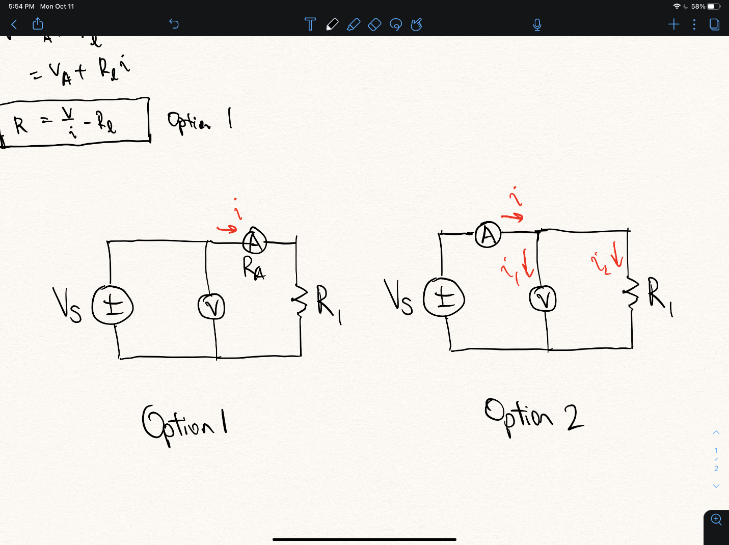

$$V=iR_{eq}=i\left(R_{A}+R_{l}\right)$$

Rearranging:

$$∴R_{A}=\frac{V}{i-R_{l}}$$

For resistance of voltmeter in Option 2 circuit



Using Kirchhoff’s current law:

$$i=i_{1}+i_{2}=\frac{V}{R_{V}}+\frac{V}{R_{l}}$$

Rearranging:

$$∴R_{V}=\frac{V}{i-\frac{V}{R_{l}}}$$

**II. The Experiment**

Measure the resistance of 7 resistors with the multimeter set to ohmmeter. Use the data to complete the table below and indicate the (reading) uncertainty for each measurement.

Table 1. Measured resistance of 6 resistors using an ohmmeter. All values are in $kΩ$.

|  |  |  |  |  |  |  |  |  |  |  |  |
| --- | --- | --- | --- | --- | --- | --- | --- | --- | --- | --- | --- |
| $$R_{l1}$$ | $${ΔR}_{l1}$$ | $$R_{l2}$$ | $${ΔR}_{l2}$$ | $$R_{l3}$$ | $${ΔR}_{l3}$$ | $$R_{l4}$$ | $${ΔR}_{l4}$$ | $$R_{l5}$$ | $${ΔR}_{l5}$$ | $$R_{l6}$$ | $${ΔR}_{l6}$$ |
| $$26.962$$ | $$±0.001$$ | $$101.47$$ | $$±0.01$$ | $$0.4634$$ | $$±0.0001$$ | $$2.6917$$ | $$±0.0001$$ | $$0.09975$$ | $$±0.00001$$ | $$0.2193$$ | $$±0.00001$$ |

**Question 3:**

**Choose at least 4 of these resistors to construct circuits for this experiment. Briefly justify your choice.**

We decided to use the first 4 resistors (Rl1, Rl2, Rl3, Rl4) for the convenience of quickly reading off values from the table above.

Circuit Option 1:

* Assemble circuit Option 1 (Fig. 3). Sketch or photograph it and include this sketch/photograph in your report. List the elements of the circuit in a caption.
* If you are working with a DC power supply, set it to about 6.5V.
* Measure the voltage $V$ and current $I$ for circuits with your four chosen resistors. You can use more than 4 resistors if you like. Use this information to calculate the internal resistance of the ammeter. Organize all of the data in Table 2.

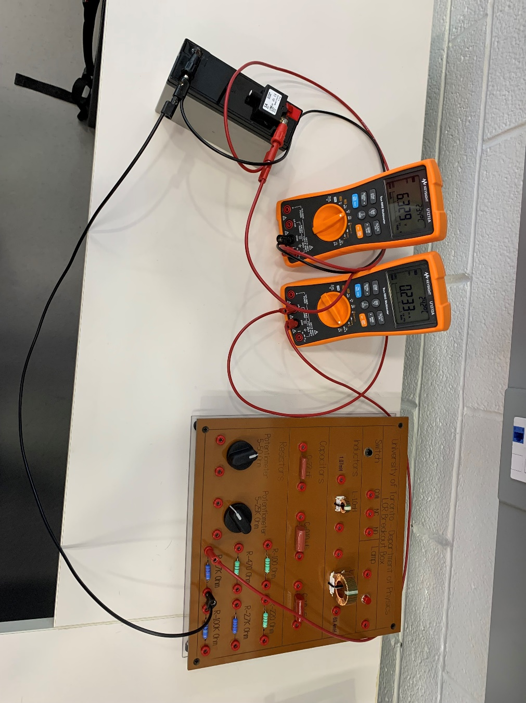

*Fig. 4. The circuit setup for Option 1. On the far left is the battery used as the power source for this circuit. Moving to the right, we used two multimeters as the voltmeter and ammeter. On the far right is the board containing the 6 resistors. The ammeter (right multimeter) is connected in series with the resistor, which together are in parallel with the voltmeter (left multimeter).*

Table 2. Measured and calculated values for circuit Option 1.

|  |  |  |  |  |  |  |  |  |
| --- | --- | --- | --- | --- | --- | --- | --- | --- |
|  | **Resistance $$R_{li},kΩ$$** | **Uncertainty $${ΔR}_{li},kΩ$$** | **Voltage $V,$ V** | **Uncertainty $ΔV,$**  **V** | **Current $I$**  **, mA** | **Uncertainty $ΔI$**  **, mA** | **Resistance of ammeter $$R_{A},kΩ$$** | **Uncertainty $${ΔR}_{A},kΩ$$** |
| **1** | 26.962 | ±0.001 | 6.316 | ±0.0005 | 0.230 | ±0.0005 | 0.4989 | ±0.0005 |
| **2** | 101.47 | ±0.01 | 6.318 | ±0.0005 | 0.059 | ±0.0005 | 5.615 | ±0.01 |
| **3** | 0.4634 | ±0.0001 | 6.319 | ±0.003 | 13.581 | ±0.002 | 0.001882 | ±0.002 |
| **4** | 2.6917 | ±0.0001 | 6.318 | ±0.001 | 2.344 | ±0.0005 | 0.003693 | ±0.001 |
|  |  |  |  |  |  | **Average:** | 1.530 | ±0.0034 |

* Plot $V$ vs $I$ and apply a linear fit to determine the slope $m_{1}$ and its uncertainty. Check two goodness of fit criteria.

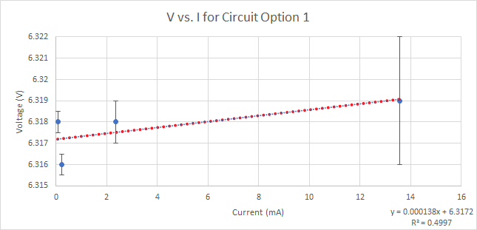

*Fig. 5. Plot of measured $V$ values against measured $I$ values for circuit Option 1.*

Chi-Squared Goodness of Fit Criterion

The fitting function has an equation of $y=0.000138x+6.3172$. In order for this line of best fit to be a good fit, the value of $χ^{2}$ should be around the number of degrees of freedom of the system, $ν=N-2$, where $N$ is the number of data points. For this system, $ν=4-2=2$. Substituting values into the equation for $χ^{2}$, we get:

$$χ^{2}=\sum_{i=1}^{N}{\frac{{\left[y_{i}-f\left(x_{i}\right)\right]}^{2}}{σ_{y_{i}}^{2}}}≈8.8055$$

This value is large compared to the number of degrees of freedom of the system, indicating that the uncertainties are too small. Therefore, the fitting function is not a good fit for the data.

Residuals Graph Goodness of Fit Criterion

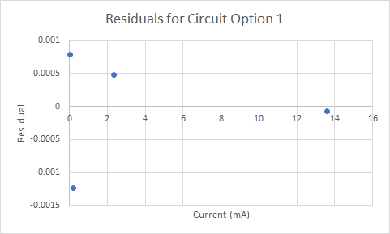

*Fig. 6. Residuals of the $V$ vs $I$ plot for circuit Option 1.*

The residuals graph does not display any obvious trends or patterns, implying that much of the uncertainty was random/statistical. In this respect, our line of best fit meets the criterion for a good fit.

Circuit Option 2:

* Assemble circuit Option 2 (Fig. 3).
* Measure the voltage $V$ and current $I$ for circuits with your four (or more) chosen resistors. Use this information to calculate the internal resistance of the voltmeter. Organize all of the data in Table 2.

Table 3. For Circuit Option 2

|  |  |  |  |  |  |  |  |  |
| --- | --- | --- | --- | --- | --- | --- | --- | --- |
|  | **Resistance $$R_{li},kΩ$$** | **Uncertainty $${ΔR}_{li},kΩ$$** | **Voltage $V,$ V** | **Uncertainty $ΔV,$**  **V** | **Current $I$**  **, mA** | **Uncertainty $ΔI$**  **, mA** | **Resistance of voltmeter $$R_{V},kΩ$$** | **Uncertainty $${ΔR}_{V},kΩ$$** |
| **1** | 26.962 | ±0.001 | 6.322 | ±0.0005 | 0.233 | ±0.0005 | -4276.95 | ±0.0005 |
| **2** | 101.47 | ±0.01 | 6.322 | ±0.0005 | 0.061 | ±0.001 | -4847.68 | ±0.01 |
| **3** | 0.4634 | ±0.0001 | 6.300 | ±0.001 | 13.590 | ±0.002 | -1219.47 | ±0.002 |
| **4** | 2.6917 | ±0.0001 | 6.318 | ±0.0005 | 2.345 | ±0.0005 | -2851.71 | ±0.001 |
|  |  |  |  |  |  | **Average:** | -3298.95 | ±0.0034 |

* Plot $V$ vs $I$ and apply a linear fit to determine the slope $m_{2}$ and its uncertainty. Check two goodness of fit criteria.

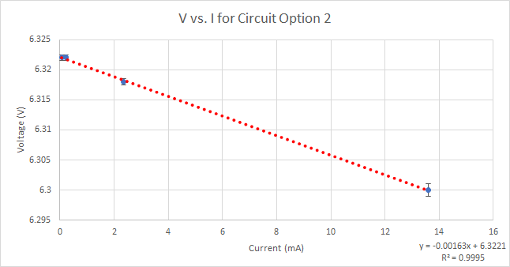

*Fig. 7. Plot of measured $V$ values against measured $I$ values for circuit Option 1.*

Chi-Squared Goodness of Fit Criterion

The fitting function for circuit Option 2 has an equation of $y=-0.00163x+6.3221$. Similar to circuit Option 1, this system has 2 degrees of freedom. Plugging in values into the formula for $χ^{2}$ gives:

$$χ^{2}=\sum_{i=1}^{N}{\frac{{\left[y_{i}-f\left(x_{i}\right)\right]}^{2}}{σ_{y_{i}}^{2}}}≈0.6242$$

This value is small compared to the number of degrees of freedom of the system, indicating that the data has likely been overfitted. Therefore, the fitting function is not a good fit for the data.

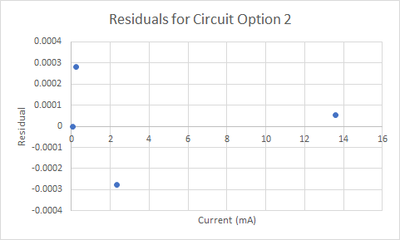

*Fig. 8. Residuals of the $V$ vs $I$ plot for circuit Option 2.*

No obvious trends can be seen in this graph of the residuals for circuit Option 2 – the uncertainty was mostly random/statistical. Therefore, our line of best fit meets the criterion for a good fit for this metric.

**III. Analysis**

* Derive a relationship among $m_{1}$, $R_{V}$ and $R_{1}$ to find the output resistance with its uncertainty. Show the steps of your error propagation calculation for the uncertainty of $R_{1}$***.***

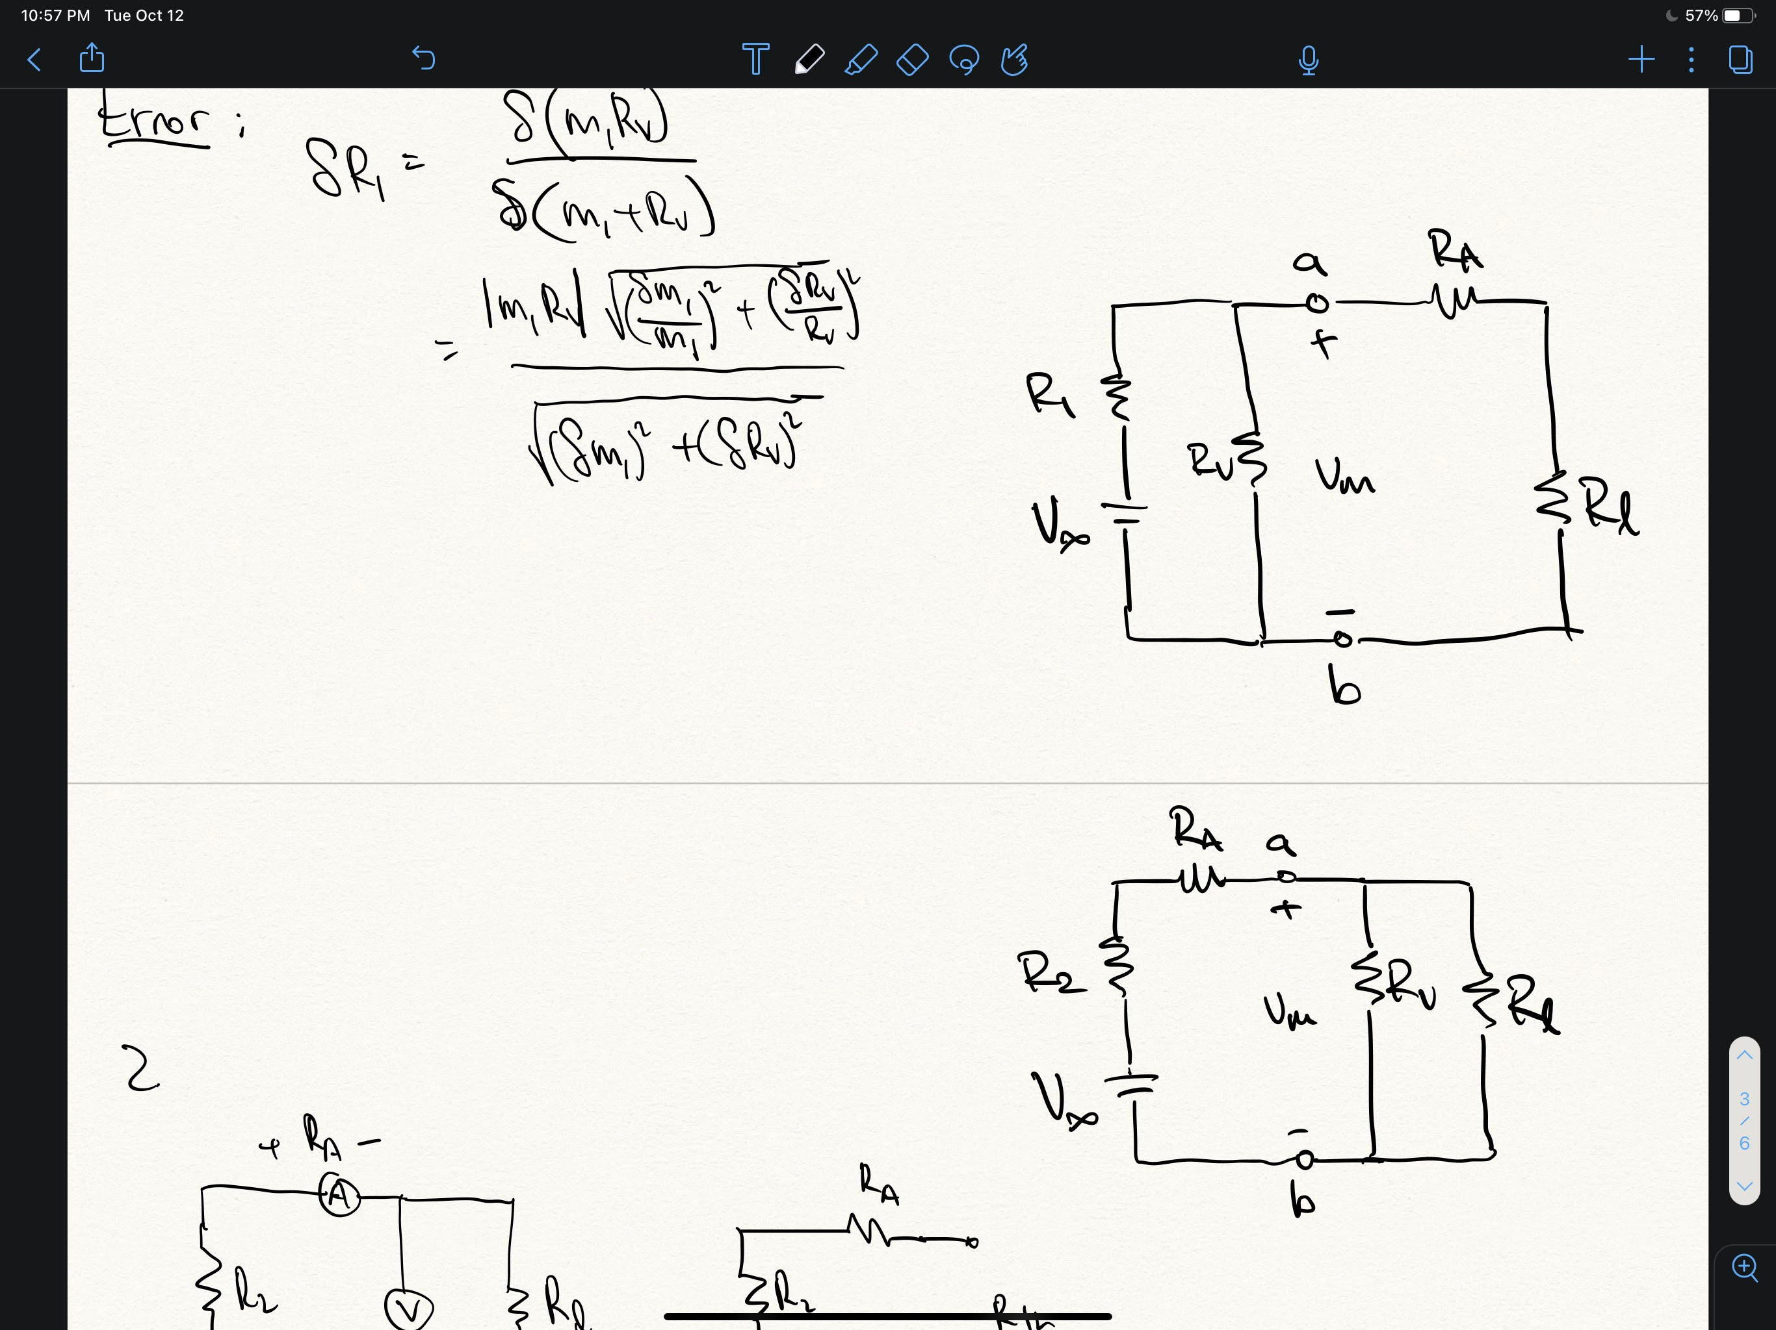

Let $V_{m}$ be the measured voltage. Consider the Thevenin equivalent circuit as seen on the left side of points a and b. We can see that the Thevenin resistance would be:

$$R_{th}=\frac{R_{1}R_{V}}{R_{1}+R_{V}}$$

Using Kirchhoff’s voltage law, we can write an expression for the Thevenin equivalent circuit:

$$V_{m}=V_{th}-R_{th}I_{m}$$

Comparing this equation with the equation of the line of best fit of $V$ vs $I$**,**

$$V_{m}=m_{1}I_{m}+b$$

we see that it must be the case that:

$$m_{1}=-R_{th}=\frac{R_{1}R_{V}}{R_{1}+R_{V}}$$

$$∴R_{1}=-\frac{m_{1}R_{V}}{m_{1}+R_{V}}$$

Below are the steps of the error propagation calculations for the uncertainties of both $R_{1}$ and $R_{2}$:

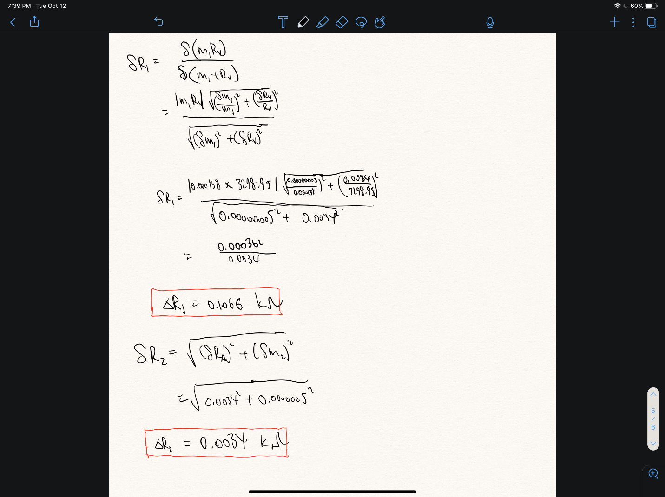

* Derive a relationship among $m_{2}$, $R_{A}$ and $R_{2}$ to find the output resistance with its uncertainty. Show the steps of your error propagation calculation for the uncertainty of $R_{2}$*.*



Using the same method used for the Option 1 circuit, we consider the Thevenin equivalent circuit as seen on the left side of points a and b and express the Thevenin resistance in terms of $R_{2}$ and $R_{A}$. We then use Kirchhoff’s voltage law to write an expression for the Thevenin equivalent circuit, compare it to the equation of the line of best fit of $V$ vs $I$, and deduce an expression for $R_{2}$:

$$R_{th}=R_{2}+R_{A}$$

$$V_{m}=V_{th}-R_{th}I_{m}$$

$$V_{m}=m_{2}I_{m}+b$$

$$m_{2}=-R_{th}=-(R_{2}+R_{A})$$

$$∴R_{2}=-m_{2}-R_{A}$$

* Show the output resistance of the battery (or DC power supply) as: $R_{1}$**=** ( **___ ± ___** ) Ω and $R_{2}$**=** ( **___ ± ___** ) Ω.

Plugging in values into the expressions derived above for $R_{1}$ and $R_{2}$, we obtain:

$$R_{1}=-0.000138 kΩ±0.1066 kΩ$$

$$R_{2}=-1.5282 kΩ±0.0034 kΩ$$

* Write a brief conclusion on the difference between the two results.

With ideal multimeters and no statistical uncertainties, the load resistance values, $R_{1}$ and $R_{2}$ should be the same. However, real multimeters are imperfect and draw current and voltage. Additionally, our statistical and measurement uncertainties are relatively high. Therefore, the calculated load resistances differed significantly – they were *not*within experimental uncertainties. One should expect the load resistance to be near zero for an ideal battery to minimize power loss. Our calculated values were relatively low, which is expected based on the behaviour of voltage sources.